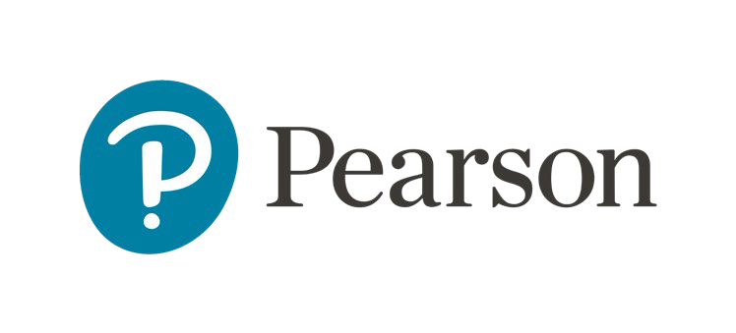

Get started in Canvas with MyLab and Mastering through VitalSource
These instructions are for new and returning Partner Integration or First Day Access. Instructors. Please use the contents to find your starting point. Beginning with these starting points will help you have a successful integration.
Contents
Priority Start Actions 1
Have a Pearson account 1
Find your partner app 1
Hide MyLab and Mastering in Canvas menu 1
Launch Pearson content 1
Link User Accounts, if needed 2
Create or Copy Course 3
Managing your Pearson Materials 4
Home 4
Grade Sync 5
Help & Support 5
Learn More 6

Priority Start Actions

Have a Pearson account
A Pearson account is needed to create a Pearson Partner Integration course. Verify your existing account at mlm.pearson.com or create a new Pearson account.

Find ‘Instant Access Complete’ in your Canvas’s navigation menu

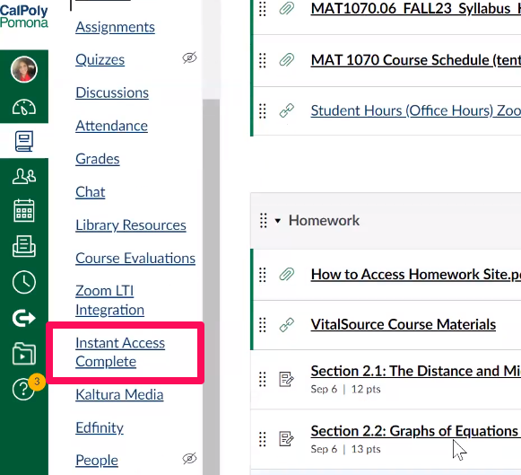

If you don’t have the ‘Instant Access Complete’ link in your Canvas’s navigation menu, follow these steps.

- Select ‘Settings’ in your Canvas’s navigation menu
- Select the ‘Navigation’ tab
- Locate ‘Instant Access Complete’ on the list and drag it up into the active link list.
- Select ‘Save’ to save your changes

Hide MyLab and Mastering in Canvas menu
The presence of the MyLab and Mastering link or other Pearson tools and assignments can be confusing for students and is unnecessary for partner integration. Use the navigation settings in your Canvas course to hide or remove the link from student access.

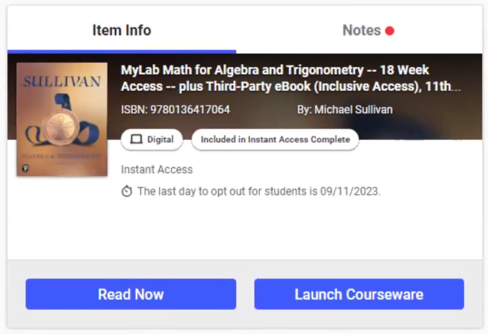
Launch Pearson content
- Select ‘Launch Courseware.’

Link user accounts, if needed
- Link your Canvas user account to your existing Pearson account by entering your Pearson Username and Password.
- Select Link Accounts.
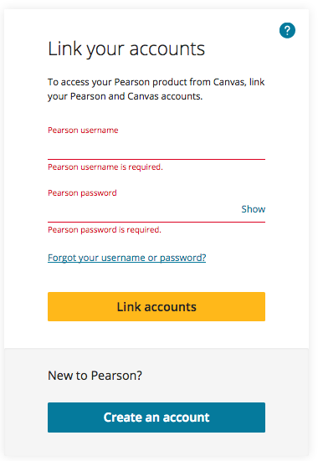
- Select Continue.
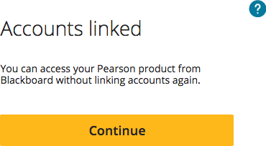
If prompted, read and acknowledge the Privacy Policy and then Continue to agree to Pearson’s Privacy Policy.

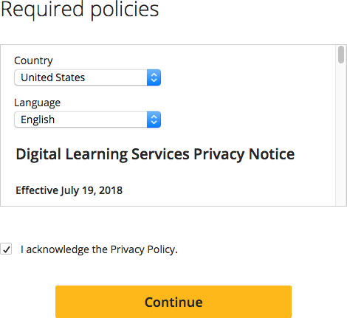

Create or Copy Course
Do NOT pair a coordinator or Instructor only course with your Canvas course. Coordinator courses should be set up separately at mlm.pearson.com with the same course materials. Member sections must then be copied from the coordinator course by entering the
coordinator course ID into the “Enter the course ID for the existing course” field.
- On the create a course screen, choose:

  - Create a new course, Select to create a new course for the listed textbook.
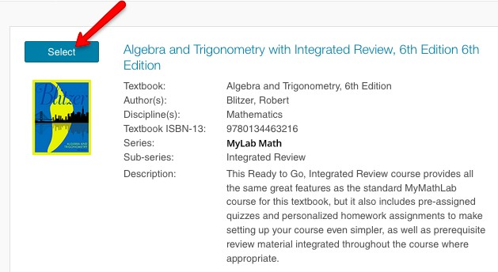
  - Copy an existing course, enter a course ID into the search field.
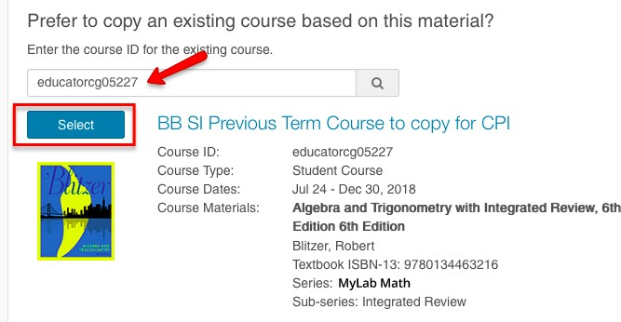
If you are unsure of the course ID of the previous course:
  - Sign-in to mlm.pearson.com. Locate your previous course, and your course ID will be displayed as your last name plus 5 digits (ex: Smith12345).
  - If using another Instructors course ID, ensure that their course is allowed for copy from the course details.
- Select Student-use course type and enter the desired course name, description, and dates.
- Select Create Course.

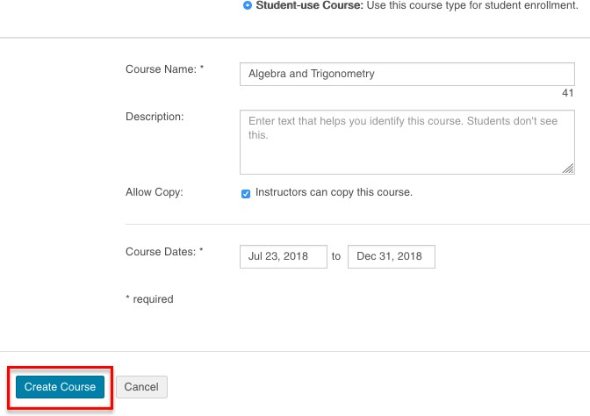
- Wait until your course is created.
You'll receive an email confirmation when the course is ready.

Managing your Pearson Materials
Pearson materials can be accessed via Launch courseware from the VitalSource app.
- Select Open MyLab & Mastering to launch your Pearson course.
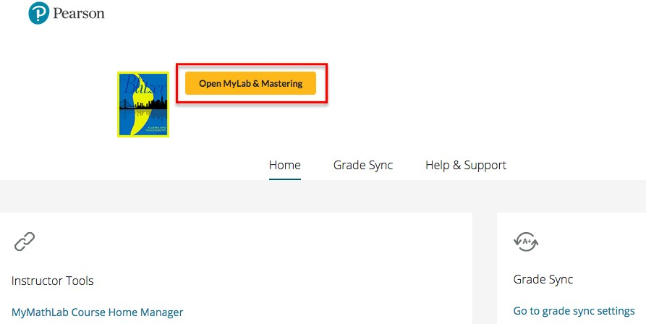
Your course management tools are displayed in three parts: Home, Grade Sync, and Help & Support.

Home
Home provides content links to instructor and student resources that launches Pearson materials.

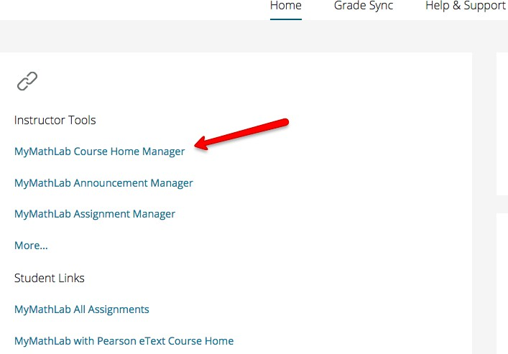

Grade Sync
To enable Grade Sync for this course:
- Select the Grade Sync button.
- Select On for automatic grade sync.
- Check boxes for assignments to sync in the Items to Sync section.

  - After you set up grade sync, it can take up to 15 minutes for your assignment to appear on the grade sync tab.
- Select Sync Grades Now to refresh the synced grades immediately.
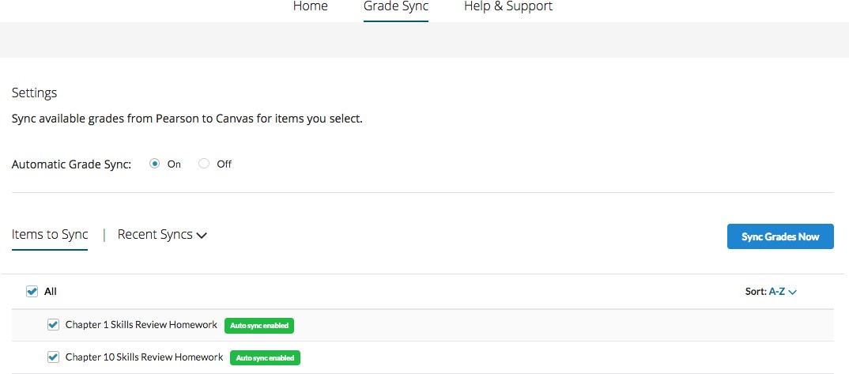
Students will be able to open Pearson assignment links from the Canvas assignments page after the first grade sync.
Go to the Canvas Assignments or Grades pages to see the synced items and grades. Grades go through a queue process, so it can take some time for submitted grades to sync to Canvas.
- Let your students know there may be a short (15-30 minute) delay between finishing/submitting an assignment and their grades updating in the Canvas Grades page.

Help & Support
Help & Support areas are included to access Instructor Help, Student Help, or Support.

Get Diagnostics provides the course information specific to this course and user. Download the diagnostics as a .txt file. Pearson Support will request this diagnostics file when opening a new Support case.
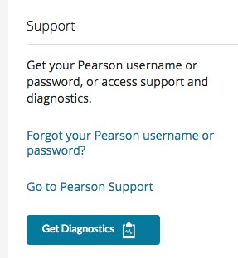

Learn More
- Learn more about teaching with your Pearson course through:
  - MyLab and Mastering quick start guides and webinars.
  - Help.
- Have accessibility questions? Email disability.support@pearson.com.
- Contact Pearson Support.

Copyright © 2021 Pearson Education, Inc. All rights reserved.

